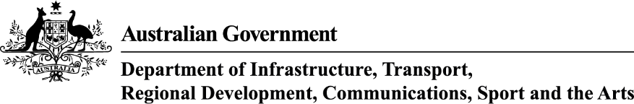
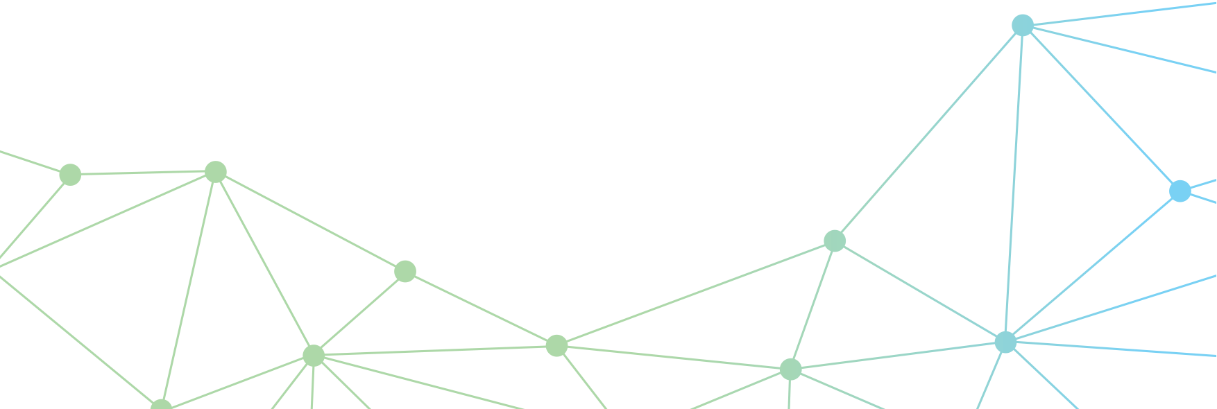

Drone Privacy Guidelines
  - Guidelines
2026
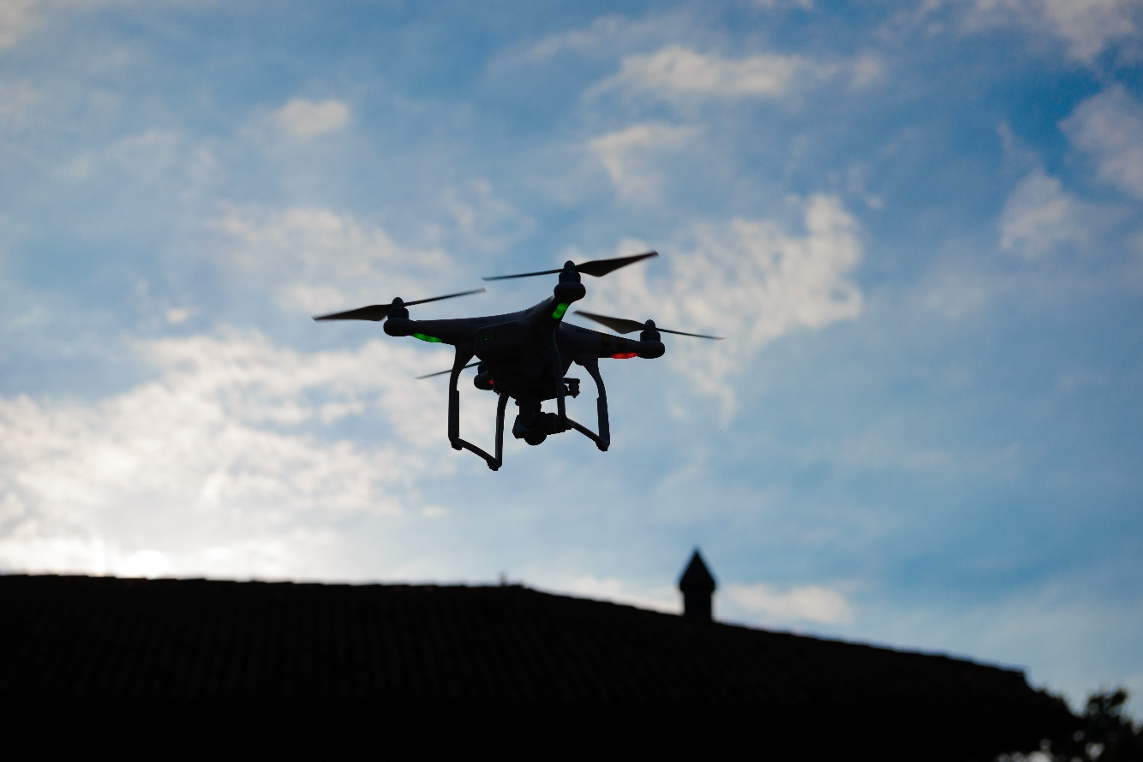

© Commonwealth of Australia 2026
February 2026 / INFRASTRUCTURE 2026

Ownership of intellectual property rights in this publication
Unless otherwise noted, copyright (and any other intellectual property rights, if any) in this publication is owned by the Commonwealth of Australia (referred to below as the Commonwealth).

Disclaimer
The material contained in this publication is made available on the understanding that the Commonwealth is not providing professional advice, and that users exercise their own skill and care with respect to its use, and seek independent advice if necessary.
The Commonwealth makes no representations or warranties as to the contents or accuracy of the information contained in this publication. To the extent permitted by law, the Commonwealth disclaims liability to any person or organisation in respect of anything done, or omitted to be done, in reliance upon information contained in this publication.

Use of the Coat of Arms
The Department of the Prime Minister and Cabinet sets the terms under which the Coat of Arms is used. Please refer to the Commonwealth Coat of Arms - Information and Guidelines publication available at https://www.pmc.gov.au/.

Creative Commons licence
With the exception of (a) the Coat of Arms; and (b) the Department of Infrastructure, Transport, Regional Development, Communications, Sport and the Arts photos and graphics, copyright in this publication is licensed under a Creative Commons Attribution 4.0 Australia Licence.
Creative Commons Attribution 4.0 Australia Licence is a standard form licence agreement that allows you to copy, communicate and adapt this publication provided that you attribute the work to the Commonwealth and abide by the other licence terms.
Further information on the licence terms is available from https://creativecommons.org/licenses/by/4.0/
This publication should be attributed in the following way: © Commonwealth of Australia 2026

Contact us
This publication is available in PDF and Word format. All other rights are reserved, including in relation to any departmental logos or trademarks which may exist. For enquiries regarding the licence and any use of this publication, please contact:
Director – Internal Comms and Creative Services
Communication Branch
Department of Infrastructure, Transport, Regional Development, Communications, Sport and the Arts
GPO Box 594
Canberra ACT 2601
Australia
Email: publishing@infrastructure.gov.au
Website: https://www.infrastructure.gov.au/

Table of Contents
Table of Contents 3
Introduction 4
Background 5
Application 5
Drone Privacy Principles 6
1. Inform others or obtain consent (where practical, proportional to the drone operation) 7
2. Minimise viewing, recording and/or collection of data 8
3. Use data only for the original purpose 9
4. Handle data securely 10
5. Know the laws and rules 11
6. Be aware of the Privacy Act 1988 and the Australian Privacy Principles 12
Legislation 13
Privacy 13
Surveillance Devices 13
Breaches 13
Serious Invasions of Privacy 14
Personal Information, Private Conversations and Private Activities 15
Collection of personal information 17
Some common misconceptions with drone privacy 17
Contact us 19

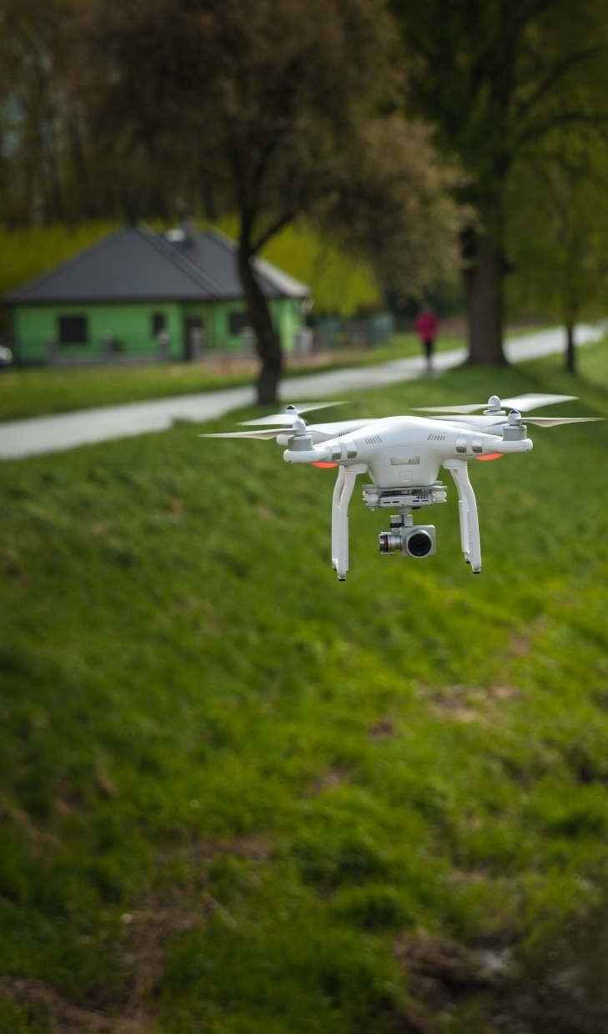
Introduction
These Guidelines provide a set of easy-to-follow principles that will help drone operators and the community understand and manage privacy concerns.
The Guidelines draw on Australian privacy and surveillance rules and laws already in place – they do not introduce new requirements.
The Guidelines provide six Drone Privacy Principles (DPPs) and include content on personal and private information and common misconceptions about drones and privacy.
Although the DPPs are not enforceable, complying with them will help meet community expectations. The Guidelines also aim to help raise awareness of privacy safeguards associated with drones. This will help build confidence in drones and allow Australia to benefit from them.
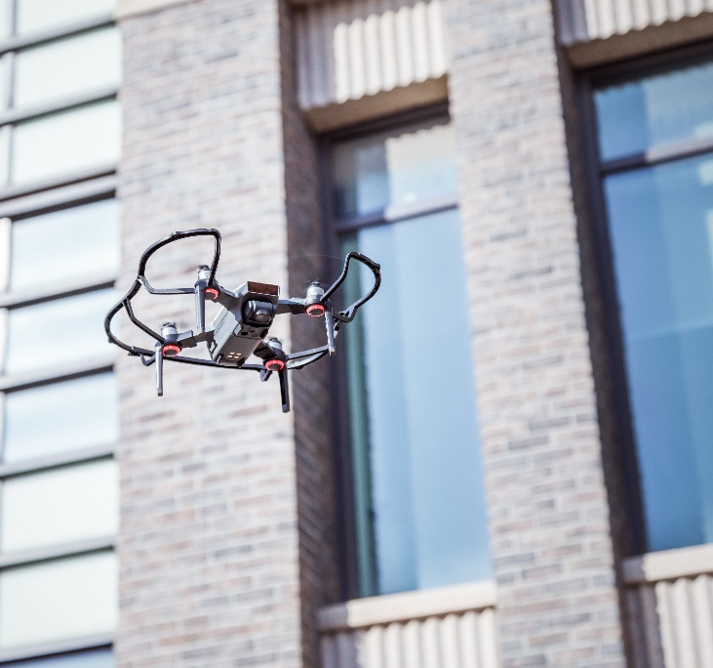
The Guidelines were developed by the Department of Infrastructure, Transport, Regional Development, Communications, Sport and the Arts, informed by consultation with the public, state and territory governments and industry.
Please note, this document is not legal advice.

Background
No matter the application, whether for business or fun, you should operate your drone in a way that respects privacy and protects private information. This includes being aware of existing Commonwealth, state and territory laws that apply where you fly.
Drones have a unique potential to impact privacy, which can at times, increase community sensitivity to their use.
Historically, the drone community, including hobbyists, has long demonstrated a high level of
self-policing when it comes to privacy, which has been largely successful. However, the boost in recreational drone uptake across Australia in the past decade causes an increase in the general public interacting with these new technologies.
By clearly identifying the requirements that under Commonwealth, state and territory privacy, and surveillance laws, drone operators and the broader community will be better equipped to manage potential negative interactions.
Importantly, the laws that apply differ between states and territories. A summary of some applicable laws and a summary of state and territory privacy advice is available on the Australian Government’s Drone Information Hub.
The Guidelines include six Drone Privacy Principles (DPPs), which have been developed with the Australian Privacy Principles (APPs) from the Privacy Act 1988 as a foundation. The DPPs are underpinned by relevant principles-based law, privacy, and surveillance legislation and regulations.
These Guidelines do not cover other rules and regulations on drone use, for example safety laws, approvals and registration. Operators should make themselves aware of all their other obligations before they fly.

Application
Drone operators broadly fall under two user groups:
- commercial – those who use their drones for business purposes
- recreational – those who use their drones for personal purposes
Each group has different obligations. While the Guidelines can be applied broadly to both commercial and recreational operators, the DPPs make distinctions where relevant.
If, after reading this document, you are still unsure about whether a drone operation is in breach of relevant laws, please seek further advice from a relevant state or territory privacy body, the Office of the Australian Information Commissioner or legal advice.
The Guidelines and DPPs are not exhaustive and some drone operations may be subject to additional obligations now or in the future. Compliance with the DPPs does not guarantee compliance with the applicable laws for all drone operators and types of operation.
The DPPs should be read together with laws or provisions relating to specific operations, and the Civil Aviation Safety Authority’s (CASA) guidance for drone use, including the basic drone safety rules.

Drone Privacy Principles
- Inform others or obtain consent
- Minimise viewing, recording and/or collection of data
- Only use data for the original purpose
- Handle data securely
- Know the laws and rules
- Be aware of the Privacy Act 1988 and the Australian Privacy Principles (APPs)

1. Inform others or obtain consent (where practical, proportional to the drone operation)
Drone operators should have a clear idea about the type of information that may be captured before flying their drone, and plan appropriately for it.
Drone operators should wherever possible:
  - give appropriate notice,
  - seek express or implied consent,
  - inform the impacted party if a drone has inadvertently operated in a way that has captured or collected personal information.
More general information can be found under Part 2 of the Australian Privacy Principles.
 | Application for Drone Users
Recreational | - Recreational drone operators must comply with CASA’s drone safety rules, which includes flying at least 30 metres from any person. Depending on the drone equipment this may mean if data is collected, it cannot be used to identify someone.  - Recreational drone operators should seek to give notice or seek consent either in person or in writing, as appropriate to the activity.  - When complying with CASA’s drone safety rules, recreational drone operators should always fly their drone within visual line-of-sight and, where possible, alert people in the area not involved with the operation and gain their consent if required.  - Where possible, operate the drone in an area visible to the surrounding community while ensuring compliance with CASA’s drone safety rules. Misunderstanding of a drone’s operation has the potential to negatively impact on building the technologies social license.
Commercial | - Commercial operators should consider strategies that are practical and applicable to the scope and duration of their operation.  - For some commercial operations, this may include public awareness campaigns and communication strategies, as appropriate to the operation.  - Commercial operators may consider communication strategies that include the following information, where appropriate:  - Nature and purpose of the operations  - Regulatory and other approvals  - Location, time/s and frequencies of flights (where applicable/possible)  - Drone specifications (camera, microphone, speed)  - Data capture, collection, storage and use (see also Principle 2)  - Commercial operators should consider having an easy way for community members to express concern and seek further information about drone operations.

2. Minimise viewing, recording and/or collection of data
Unless consent is given, drone operators should try to avoid using a drone to view, record and/or collect personal or private information of others.
Operators should minimise the data collected and stored. If personal or private information is inadvertently collected, the drone operator should, in the first instance, de-identify or destroy the data. If the data is required, the drone operator should seek the consent of the affected party to the best of their ability.
More general information can be found under Part 2 of the Australian Privacy Principles.

 | Application for Drone Users
Recreational | - Recreational drone operators should avoid using recording equipment to view and/or collect personal or private information.  - Neighbourly drone use is encouraged. Recreational drone operators should avoid flying over private property. In the event this cannot be avoided, operators should avoid directing equipment capable of viewing, recording and/or collecting private or personal information towards sensitive locations, i.e., backyards, windows, etc.  - Anti-social behaviour is discouraged as it is, in most cases, already illegal. This includes behaviour like harassment, intimidation, voyeurism, nuisance, serious invasions of privacy and generally dangerous activity.
Commercial | - Commercial operators should carry out a privacy impact assessment before using a drone. This is to minimise the collection of unnecessary personal or private information and identify privacy risks and strategies to avoid those risks.  - Commercial operators, to the best of their efforts, should only view, record and/or collect data that is necessary for their operation.  - Commercial operators who view, record and/or collect data using drones may choose to include the following into their privacy policy:  - The type of data that may be viewed, recorded and/or collected  - The reason for data viewing, recording and/or collection  - Practices for retaining and sharing recorded and/or collected data  - Parties with whom data may be shared.

3. Use data only for the original purpose
Drone operators that have obtained personal or private information for one purpose should not use or disclose it for a different purpose.
If personal or private information has been captured (whether deliberately or inadvertently), it should not be disseminated or made public without the consent of the affected people.
More general information can be found under Part 3 of the Australian Privacy Principles.

 | Application for Drone Users
Recreational | - Recreational drone operators should obtain the consent of affected people before publishing or disseminating data that contains private or personal information captured by the drone.  - If consent cannot be obtained, private or personal information within the data should be de-identified before sharing or disseminating it.  - Drone operators can contact the Office of the Australian Information Commissioner or their state or territory privacy body to discuss how to handle personal or private information.
Commercial | - Commercial operators should only share data that is necessary to complete their contract or carry out their ongoing operation.  - In the event a person’s private or personal information is captured for reasons other than continued operation or contracting, commercial operators may need to notify the person that their information is being used. If further actions are required, the operator may need to seek approval for further distribution or use.

4. Handle data securely
Drone operators take reasonable steps to ensure information is stored securely and protected from misuse, interference, loss, unauthorised access or disclosure.
Drone operators should also only retain personal or private information necessary for their operation.
More general information can be found under Part 3 of the Australian Privacy Principles.

 | Application for Drone Users
Recreational | - Personal or private information that has been collected should be stored in a managed environment until it can be de-identified or destroyed.
Commercial | - If the information is no longer operationally required or required for regulatory or safety analysis reasons, a commercial operator should take reasonable steps to ensure it is de-identified or destroyed.  - Commercial operators that have the potential to collect personal or private information should manage risks to that information by implementing a data management process that contains reasonable administrative, technical, and physical safeguards appropriate to:  - the operator’s size and complexity,  - the nature and scope of its activities, and  - the sensitivity of the covered data.

5. Know the laws and rules
Drone operators that are unsure whether their operations will have privacy implications should consult the laws in the state, territory or council intended for operation.
Laws and rules relating to privacy may not mention drones but may still capture drone activities.
Contacting the relevant government agency or getting legal advice may be necessary before undertaking your operation if there is a possibility of personal or private information being captured.

 | Application for Drone Users
Recreational | - Recreational drone operators must fly in accordance with CASA’s drone safety rules, or the rules of an approved aviation administration organisation.  - CASA drone safety rules support aviation safety outcomes but do not necessarily cover other laws, regulations and by-laws that apply to flying drones in local jurisdictions, including laws relating to privacy and data.  - A summary of some of the laws that may apply to operators is available on the Drones Information Hub.
Commercial | - Commercial drone operators who operate drones that may collect personal information should ensure they comply with local laws and rules relating to privacy. These laws may go further than standard drone regulatory approvals.  - A summary of some potentially applicable laws is available on the Drones Information Hub.

6. Be aware of the Privacy Act 1988 and the Australian Privacy Principles
Drone operators should understand their rights and responsibilities under the Privacy Act 1988 (the Privacy Act) and the Australian Privacy Principles (APPs).
The APPs are a technology-neutral, principles-based law that govern standards, rights and obligations around:
- the collection, use and disclosure of personal information
- an organisation or agency’s governance and accountability integrity and correction of personal information
- the rights of individuals to access their personal information
More general information can be found under the Australian Privacy Principles.

 | Application for Drone Users
Recreational | - A statutory tort for serious invasions of privacy, created under the Privacy Act 1988, is applicable to individual operators acting in a private capacity. This tort provides a pathway for individuals to have a reasonable cause of action (i.e. a right to sue) against other individuals when their privacy has been seriously breached.  - Other than the statutory tort for serious invasions of privacy, the Privacy Act 1988 does not apply to recreational operators.  - For more information, consult with the Office of the Australian Information Commissioner.
Commercial | - The Privacy Act applies to Australian Government agencies (and the Norfolk Island administration) and organisations with an annual turnover more than $3 million, as well some small business operators.  - Commercial drone operators who use drones to collect data should familiarise themselves with their responsibilities under the Privacy Act to determine whether data collected through their drone operations may be subject to provisions under the Privacy Act.

Legislation

Privacy
Giving notice of the collection of people’s personal information is a requirement under privacy legislation. Recording personal information or a private conversation or activity without consent may constitute an offence (depending on the applicable state or territory surveillance devices legislation and the information recorded). If personal information has been captured (whether deliberately or inadvertently) it is possible for it to count as an offence, especially if the recording is published or shared (unless all parties consent).
Remote sensing equipment used on drones can be optical (e.g. cameras) or non-optical (e.g. light detection and ranging (LiDAR)). Data used for navigation purposes (i.e. geological or elevation data) can be collected using non-camera-based sensors that are designed to produce images without identifiable features. This technology can mitigate the capture of personal information and may reduce the application of certain privacy legislative requirements.
It should be noted that even if no personal information is captured, the use of a drone to intrude upon someone’s seclusion may result in a cause of action (i.e. a right to sue) if the intrusion is considered to breach other elements of the statutory tort for serious invasion of privacy under the Privacy Act 1988.

Surveillance Devices
Drone operators should be aware that equipment attached to a drone that can record or transmit sound or a visual image or potentially geolocation data, such as camera-based recording equipment, may deem the drone a recording device for the purposes of surveillance devices legislation.
It is important to note that depending on the state or territory, regulation of surveillance devices may be different to those dealing with handling or collecting personal information. Despite the potential differences, both serve the same purpose of protecting personal information.
While information privacy legislation only applies to the entities specified in the relevant Commonwealth, state or territory legislation (and is unlikely to capture recreational drone users), surveillance devices legislation generally applies to all persons.

Breaches
While conducting their operations, both commercial and recreational drone operators should be aware that inappropriate drone use could breach Commonwealth, state and territory laws. This may be additional to privacy specific laws, such as trespassing, harassment, intimidation, nuisance, and endangering safety.
Some laws mention drones specifically, some do not. For example, drones may be considered aircraft, recording equipment, cameras, or surveillance devices in different contexts. Even if laws do not explicitly mention drones, they may still apply. Generally speaking, the use of drones in many situations is regulated by existing laws, in the same way it would be if the action was conducted in person or using other devices or equipment. Inappropriate use of a drone could also result in committing a criminal offence, for example unlawful listening to or recording of private conversations, unlawful observing, recording private acts, or distributing intimate images.
If a recreational operator has breached CASA safety rules, or a commercial operator has breached the terms of their remotely piloted aircraft operator's certificate (ReOC), CASA can issue penalties by withdrawing licenses and registration. In the event of a drone becoming a hazard to other aircraft, fines over $30,000 and imprisonment of up to 2 years can apply.

Serious Invasions of Privacy
The Privacy Act 1988 was amended in 2025 to include a statutory tort for serious invasions of privacy. Unlike other parts of the Privacy Act 1988 which only apply to Australian Privacy Principle (APP) entities, this tort applies to all individuals, including recreational drone users. A serious invasion of privacy is now legally actionable without proof of damage, meaning that people who have been impacted by drone operators misusing their capabilities can be owed compensation without needing to provide evidence that they have suffered harm.
It is important to note that the tort does not allow an individual to sue those under 18 years old, small businesses, journalists, or enforcement bodies.
According to the tort, an individual (the plaintiff) has a cause of action (a right to sue) against another person (the defendant) if the defendant has invaded the privacy of the plaintiff by:
- Seriously intruding on the plaintiff’s seclusion, and/or
- misusing the plaintiff’s personal information
in circumstances where:
- a person in the position of the plaintiff would have had a reasonable expectation of privacy,
- the defendant was intentional or reckless when invading the plaintiff’s privacy,
- if the invasion was serious, and
- there was no competing ‘public interest’, such as those listed in section 7(3) of Schedule 2 of the Privacy Act, that would outweigh the importance of maintaining the plaintiff’s privacy, including, and not limited to, freedom of the media, public health and safety, national security, etc.
The court process is the primary determinant of whether an invasion of privacy can be considered serious or not, as such, the tort provides considerations for the decision. An invasion of privacy can be considered serious if:
- the invasion is likely to cause a person offence, distress, or harm to dignity,
- whether the defendant knew, or should have known, that the invasion of privacy was likely to offend, distress, or harm the dignity of the plaintiff, or
- if the invasion of privacy was intentional and/or malicious.
Before actioning the above options, individuals should seek specific legal advice or contact relevant state or territory bodies if they have any concerns or questions. Additionally, it is important to read and understand any new additions to the Privacy Act 1988 before continuing with legal action.

Personal Information, Private Conversations and Private Activities
Drones are capable of collecting personal information, including information relating to private conversations and activities. It’s important for a drone operator to understand what personal information is and what conversations or activities are considered ‘private’, because there are different rules that apply to each type of information.
Personal information refers to information or an opinion about an identified, or reasonably identifiable individual. The definition of personal information, and associated rules, apply:
- whether the information or opinion is true or not, and
- whether the information or opinion is recorded in a material form or not.
Personal information is information closely related to an individual that could be used to identify them. This could include (but is not limited to) an individual’s address, phone number, date of birth, credit card information, employee record information, geolocation data, photograph or voice recording.
Personal information can also include information gathered through recording or intruding upon private conversations or private activities, whether this is through audio, visual, video or transcribed formats. Such information may require drone operators to pay attention to state and territory surveillance laws, which have slightly different definitions for private conversations and private activities.
Generally, private conversations and private activities occur when:
- the parties to the conversation or activity desire for these words or acts to remain between them, and
- can reasonably expect that their words or acts will not be overheard, observed or monitored by a third party.
Individuals should seek specific legal advice or contact relevant state or territory bodies if they have any concerns or questions.

Drone operators should consider a conversation or an activity to be private if it is reasonable to assume only the people involved would want to be privy to it.
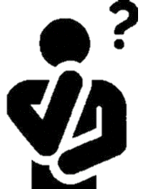 | Ask yourself:  - Could recording the activity reasonably lead to identifying the people?  - Did the people involved make an effort to move away from a public area to engage in the conversation or activity?  - Is the conversation personal or about a personal subject?  - Does the activity show an image that could reasonably lead to the identity of a person? Could you reasonably identify a person without the use of videography?  - Would you like to have this activity or a similar activity witnessed, overheard or recorded if you were involved?

Drone operators should understand not everyone will be aware of the purpose of an operation, which may lead to anxiety or caution about their operations.
Ask yourself:
- Have you, as the operator, attempted to increase awareness of your operations to those around the operation site (i.e. relevant signage, engagement with surrounding households, etc)? Can the public find out more about the operations?
- Do you, as the operator, have a clear process for receiving feedback and concerns?
- If personal information has been accidentally collected, can you notify the affected individuals?
  - If the affected individuals are not contactable, the data must be de-identified or destroyed.

Collection of personal information
The collection of personal information is regarded differently in context of private or public spaces. Information gathered in private spaces would be considered an invasion of both privacy and confidence, and enforced accordingly under general information privacy laws. Public spaces, such as concerts, or generally public locations, make information harder to protect due to Australia’s freedom of recording laws. However, regulations protecting information handling are able to secure sensitive data through censorship or deletion.
Although recorded personal information should be secured to prevent unauthorised access, disclosure or loss – the recording and collection of personal information may be prohibited under applicable state or territory surveillance or listening devices legislation.

Some common misconceptions with drone privacy
The transformative nature of drones enables new ways to conduct business and leisure activities. These Guidelines support the safe and considerate use of these technologies in line with community expectations.

A drone is like a camera. I can take pictures in public, so why is there an issue flying my camera equipped drone?
Due to their increased accessibility and ability to fly above fences, hedges and other implicit privacy boundaries, drones can observe people and record information in situations where others may have an expectation of privacy. The potential for drones to breach a person’s privacy or record personal information, even inadvertently, is significant. Used in this way, other than being possibly illegal, it may lead to negative community sentiment towards drones. Camera drones operated for recreational or commercial purposes are required to be used in a way that upholds the same reasonable expectations of privacy that would apply on the ground.
Drone operators must follow CASA’s drone safety rules or their operating conditions outlined in a ReOC. Additionally, drone operators must have a clear idea of the data they could capture before flight and seek relevant permission first, where possible.

I have delivery drones flying over my house daily. I am worried they are recording as they fly by.
Many delivery drones use either low resolution, black and white cameras or LiDAR systems for navigation. Both pieces of equipment do not enable the same type of information collection as a drone with optical cameras, as their use is specifically for navigation. These drones also do not carry microphones, and therefore cannot record audio.
If you are concerned with delivery drones in your area, you should communicate with the drone delivery operator in the first instance for more information.

All drones have high resolution cameras or recording equipment capable of capturing sensitive information from a distance.
Drones are designed with a variety of capabilities and uses, with many not having high resolution cameras or recording equipment. Some drones use low resolution cameras for flight safety whilst others use technology, such as LiDAR, to capture aerial survey data without recording personal information. Drones that fly frequently or that use these technologies are generally operated by government or commercial operators, who have the approvals to operate them for a legitimate purpose and subject to relevant conditions, including privacy laws. Some of these include agricultural and environmental applications, power line and infrastructure inspections, and delivery of food and medical items.

What avenues are there to communicate my concerns about privacy issues relating to drone operations in my area?
If you are concerned about your privacy after observing drone operations in your area, consider the following questions:
Is the drone operating for a legitimate purpose?
If the drone appears like it is part of a commercial or government operation, consider contacting the responsible operator to learn about their operation and privacy policy. If you are unsure about the operation you can contact your local jurisdiction or CASA to find out about drone operations in your area.
Can you contact the operator?
If the operator is known and able to be contacted, they may be able to provide further information on their operation. If you cannot, you can contact your local jurisdiction or CASA to find out about drone operations in your area.
Where can I voice concerns or ask questions?
The best place to provide feedback on drones, ask questions about processes, or express general opinion is through the ‘Have Your Say’ submission page on www.drones.gov.au.
CASA may be contacted to request information related to drone safety concerns or operator approvals at www.casa.gov.au/about-us/contact-us.
Further information can be found in the following links:
- Social media | Office of the Australian Information Commissioner
- Drones | Office of the Australian Information Commissioner
- Australian Privacy Principles quick reference | Office of the Australian Information Commissioner
- Emergencies and public spaces | Civil Aviation Safety Authority (casa.gov.au)

Contact us
For more information or to share your views on drones, you can have your say on the Drones Information Hub at www.drones.gov.au.
For specific privacy concerns, the Office of the Australian Information Commissioner has a combined list of relevant privacy contacts for all jurisdictions on the ‘Privacy in your state’ webpage at www.oaic.gov.au/privacy/privacy-legislation/state-and-territory-privacy-legislation.
Alternatively, you may submit your feedback or privacy concerns relating to drone use to drones@infrastructure.gov.au.This will be forwarded on to the relevant jurisdiction for appropriate action.

For more information or to share your views on drones,
you can have your say on the Drone Information Hub.

For more information about drones, including definitions and categories visit, date cited December 2022 <https://www.casa.gov.au/drones/drone-rules/drone-safety-rules/types-drones>
Drones Information Hub, ‘Privacy policy’, date cited December 2022, <http://www.drones.gov.au/policies-and-programs/policies/privacy-policy>
Civil Aviation Safety Authority, ‘Drone rules’, date cited February 2023, <https://www.casa.gov.au/drones/drone-rules>
Office of the Australian Information Commissioner, ‘Privacy in your state’, date cited March 2023, <https://www.oaic.gov.au/privacy/privacy-legislation/state-and-territory-privacy-legislation/state-and-territory-privacy-legislation>
Office of the Australian Information Commissioner, ‘Contact us’, date cited December 2022, <https://www.oaic.gov.au/about-us/contact-us>
Civil Aviation Safety Authority, ‘Drone rules’, date cited February 2023, <https://www.casa.gov.au/drones/drone-rules>
Australian Privacy Principles, ‘Part 2’, date cited December 2022, <https://www.oaic.gov.au/privacy/australian-privacy-principles/read-the-australian-privacy-principles#part-2-collection-of-personal-information> Please note, for some commercial operators (if covered under the Privacy Act 1988) compliance with the Australian Privacy Principles is compulsory.
Civil Aviation Safety Authority, ‘Drone rules’, date cited February 2023, <https://www.casa.gov.au/drones/drone-rules>
For the purposes of this paper, ‘viewing’ refers to the ability for the drone operator and/or organisation to view any content the drones may have/perceived to be able to see during its operation, ‘recording’ refers to the data being captured and stored for a defined period of time (for example for operational reasons) but not necessarily viewed or retained and ‘collecting’ refers to capturing, retaining and storing data either because this forms part of drone operation or for another purpose.
Australian Privacy Principles, ‘Part 2’, date cited December 2022, <https://www.oaic.gov.au/privacy/australian-privacy-principles/read-the-australian-privacy-principles#part-2-collection-of-personal-information> Please note, for some commercial operators (if covered under the Privacy Act 1988) compliance with the Australian Privacy Principles is compulsory.
Office of the Australian Information Commissioner, ‘Privacy impact assessments’, date cited March 2023, <https://www.oaic.gov.au/privacy/privacy-impact-assessments>
Australian Privacy Principles, ‘Part 3’, date cited December 2022, <https://www.oaic.gov.au/privacy/australian-privacy-principles/read-the-australian-privacy-principles#part-3-dealing-with-personal-information> Please note, for some commercial operators (if covered under the Privacy Act 1988) compliance with the Australian Privacy Principles is compulsory.
Office of the Australian Information Commissioner, ‘Contact us’, date cited December 2022, <https://www.oaic.gov.au/about-us/contact-us>
Office of the Australian Information Commissioner, ‘Privacy in your state’, date cited March 2023, <https://www.oaic.gov.au/privacy/privacy-legislation/state-and-territory-privacy-legislation/state-and-territory-privacy-legislation>
Australian Privacy Principles, ‘Part 3’, date cited December 2022, <https://www.oaic.gov.au/privacy/australian-privacy-principles/read-the-australian-privacy-principles#part-3-dealing-with-personal-information> Please note, for some commercial operators (if covered under the Privacy Act 1988) compliance with the Australian Privacy Principles is compulsory.
Civil Aviation Safety Authority, ‘Drone rules’, date cited February 2023, <https://www.casa.gov.au/drones/drone-rules>
Drones Information Hub, ‘Privacy policy’, date cited December 2022, <http://www.drones.gov.au/policies-and-programs/policies/privacy-policy>
Drones Information Hub, ‘Privacy policy’, date cited December 2022, <http://www.drones.gov.au/policies-and-programs/policies/privacy-policy>
Office of the Australian Information Commissioner, ‘Rights and responsibilities’, date cited December 2022, <https://www.oaic.gov.au/privacy/the-privacy-act/rights-and-responsibilities#WhoHasResponsibilitiesUnderPrivacyAct>
Federal Register of Legislation, ‘Privacy Act 1988’, dated cited February 2023, <https://www.legislation.gov.au/Details/C2022C00361>
Australian Privacy Principles, date cited December 2022, <https://www.oaic.gov.au/privacy/australian-privacy-principles/read-the-australian-privacy-principles> Please note, for some commercial operators (if covered under the Privacy Act 1988) compliance with the Australian Privacy Principles is compulsory.
Australian Privacy Principles, date cited December 2022, <https://www.oaic.gov.au/privacy/australian-privacy-principles/read-the-australian-privacy-principles> Please note, for some commercial operators (if covered under the Privacy Act 1988) compliance with the Australian Privacy Principles is compulsory.
Office of the Australian Information Commissioner, ‘Drones’, date cited December 2022, <https://www.oaic.gov.au/privacy/your-privacy-rights/surveillance-and-monitoring/drones>
Federal Register of Legislation, ‘Privacy Act 1988’, dated cited July 2025 < https://www.legislation.gov.au/C2004A03712/2025-06-10/2025-06-10/text/original/epub/OEBPS/document_1/document_1.html#_Toc200110413>
Federal Register of Legislation, ‘Privacy Act 1988’, dated cited February 2023, <https://www.legislation.gov.au/Details/C2022C00361>
These questions are intended to prompt thinking and are not intended to reflect any legal advice.
www.drones.gov.au

